# Ireland NTv2 transformation support in ArcGIS Desktop

Much Irish geographic data is stored using the legacy Irish Grid geographic coordinate system. In order for that data to participate in more broad mapping use cases, for example web mapping, it is necessary to transform that data to a more “web mapping friendly” geographic coordinate system, such as Irish Transverse Mercator (ITM) or Web Mercator/WGS84.

Here we describe how to achieve the greatest accuracy in your projections from Irish Grid by using the Ireland NTv2 transformation support in ArcGIS Desktop, specifically through the “project tool” within ArcToolbox in ArcGIS Desktop. To do so you need to utilise the set of transformation files provided within this zip folder. These transformation files can be used to transform to and from the following coordinate systems:

* Irish Grid (TM65 or TM75) to WGS 1984
* Irish Grid (TM65 or TM75) to ETRS 1989
* Irish Grid (TM65 or TM75) to Irish Transverse Mercator

## Why can I not use the out of the box projections available in ArcGIS Desktop?

The official transformation between TM75 and ETRS89 uses a polynomial which is not supported in ArcGIS. Hence the transformation files provided in this zip folder address this issue.

The polynomial has been used to generate offsets covering an extent of:

* Minimum latitude: 51.35 (51 21’ 0” N)
* Maximum latitude: 55.45 (55 27’ 0” N)
* Minimum longitude: -10.725 (10 43’ 30” W)
* Maximum longitude: -5.35 (05 21’ 0” W)
* Grid spacing: 0.025 (1’ 30”)

TM65 and TM75 are often used interchangeably, as are ETRS89 and WGS 1984. Transformation definitions for each are provided. These assume that TM65 = TM75 and ETRS89 = WGS84 within the accuracy of the transformation method.

### Files required (included in associated ZIP file Ireland_ntv2.zip:

1. tm75_etrs89.gsb
2. TM65_To_ETRS_1989_NTv2.gtf
3. TM65_To_WGS_1984_NTv2.gtf
4. TM75_To_ETRS_1989_NTv2.gtf
5. TM75_To_WGS_1984_NTv2.gtf

## Supported ArcGIS versions

These transformation files were created using ArcGIS Desktop 9.3.1.

The transformations described in this document will work in:

* ArcGIS Desktop 9.2
* ArcGIS Desktop 9.3
* ArcGIS Desktop 9.3.1
* ArcGIS Desktop 10.0
* ArcGIS Desktop 10.1

# Installation Instructions:

1. Make sure you have write access to the ArcGIS Desktop installation folder – this is usually C:\Program Files\ArcGIS.
2. Make sure that hidden folders[1] are set to be visible.
3. Ensure that ArcMap and ArcCatalog are closed.
4. Browse to the pedata\ntv2 folder in the ArcGIS installation folder.
5. In the ntv2 folder, create a new folder named ireland.
6. Copy the tm75_etrs89.gsb file to the ireland folder.

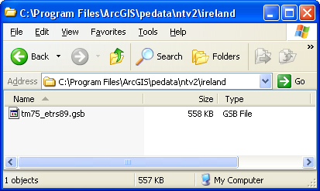

1. If using **Microsoft Windows XP**, browse to   
   C:\Documents and Settings\<your login>\Application Data\ESRI\ArcToolbox\CustomTransformations.

***Note:*** *for ArcGIS Desktop 10.0, this path will be*: C:\Documents and Settings\<your login>\Application Data\ESRI\Desktop10.0\ArcToolbox\CustomTransformations   
  
If using **Windows 7**, browse to the following, depending on what version on ArcGIS Desktop being used:

***Note:*** *for ArcGIS Desktop 10.0, this path will be*: C:\Users\<your login>\AppData\Roaming\ESRI\Desktop10.0\ArcToolbox\CustomTransformations

***Note:*** *for ArcGIS Desktop 10.1, this path will be*: C:\Users\<your login>\AppData\Roaming\ESRI\Desktop10.1\ArcToolbox\CustomTransformations

***Please note that if the directory “CustomTransformations” does not exist, it will need to be created.***

1. Copy the four (4) gtf files from the **Ireland_ntv2.zip** zip file to this folder.

# Description of the NTv2 Geographic Transformation files

The method for converting data between two coordinate systems is stored in a gtf file. The following gtf files are provided with these instructions:

|  |  |
| --- | --- |
| **GTF file name** | **Purpose** |
| TM65_To_ETRS_1989_NTv2.gtf | Transforms data from TM65 Irish Grid to ETRS 1989 geographic coordinate system |
| TM65_To_WGS_1984_NTv2.gtf | Transforms data from TM65 Irish Grid to WGS 1984 geographic coordinate system |
| TM75_To_ETRS_1989_NTv2.gtf | Transforms data from TM75 Irish Grid to ETRS 1989 geographic coordinate system |
| TM75_To_WGS_1984_NTv2.gtf | Transforms data from TM75 Irish Grid to WGS 1984 geographic coordinate system |

These are custom transformation files and should be stored in the user’s “Documents and Settings” folder (for Windows XP) or the equivalent location in Windows 7 - refer to steps 7 and 8 in the previous section.

|  |  |
| --- | --- |
| j0217328 | **Note:** Although the files listed in the table above have the naming convention:  “*Coordinate System 1_To_Coordinate System 2*”  the same file is used to transform in both directions, i.e. the same file can also be used to transform Coordinate System 2 to Coordinate System 1. |

When the user runs the Project tool in ArcToolbox, one or more of the gtf file names listed above will appear as a transformation method. Which ones appear depends on the coordinate system of the input data and the selected output coordinate system.

See section 3 of this document for examples of using the Project tool with some of these custom transformations.

# Using the NTv2 Geographic Transformation files

This section describes how to use the transformation files provided with these instructions.

The transformation files can be used to transform to and from the following coordinate systems:

* Irish Grid (TM65 or TM75) to WGS 1984
* Irish Grid (TM65 or TM75) to ETRS 1989
* Irish Grid (TM65 or TM75) to Irish Transverse Mercator

To transform data between different coordinate systems, use the **Project Tool**.

* The Project tool can be found in ArcToolbox, in Data Management Tools🡪Projections and Transformations🡪Feature
* The ArcToolbox window can be accessed from either ArcCatalog or ArcMap.

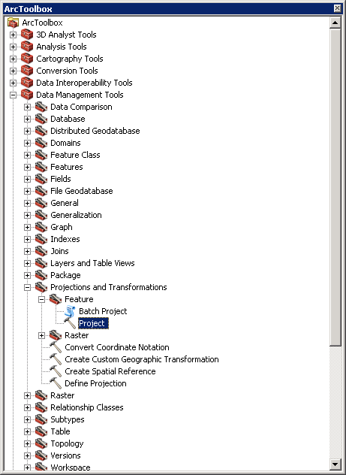

## Example 1: Transform Irish Grid to WGS 1984

1. Open the Project tool.
2. For Input Dataset or Feature Class, browse to the location of the input data.
3. The coordinate system of the input data will be recognised automatically
4. For Output Dataset or Feature Class, browse to the location in which the re-projected data will be created
5. For Output Coordinate System, browse to Geographic Coordinate Systems🡪World🡪WGS 1984.prj
6. For Geographic Transformation, choose the appropriate NTv2 transformation from the dropdown list.

In the example shown below, the input data is TM65_Irish_Grid, so “TM65_To_WGS_1984_NTv2” is selected from the dropdown list.

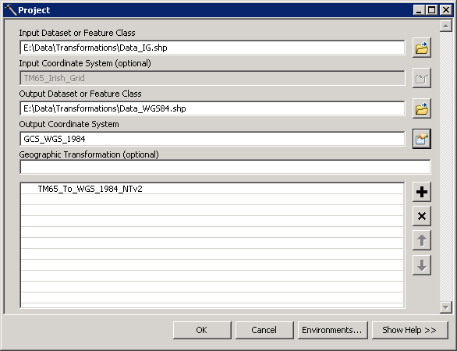

1. Click OK to execute the Project tool.

## Example 2: Transform Irish Grid to Irish Transverse Mercator (ITM)

Note: See Section 4 for details on how to create a custom IG to ITM transformation.

1. Open the Project Tool
2. For Input Dataset or Feature Class, browse to the location of the input data.
3. The coordinate system of the input data will be recognised automatically
4. For Output Dataset or Feature Class, browse to the location in which the re-projected data will be created
5. For Output Coordinate System, browse to:

Projected Coordinate Systems🡪National Grids 🡪*(Europe)* 🡪IRENET95 Irish Transverse Mercator.prj

|  |  |
| --- | --- |
| j0217328 | **Note:** the *Europe* subfolder only exists in ArcGIS Desktop 10 |

1. For Geographic Transformation:

* First choose “TM65_To_ETRS_1989_NTv2”
* Then choose “IRENET95_To_ETRS_1989”

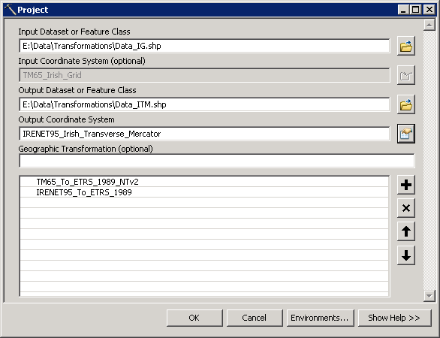

1. Click OK to execute the Project tool.

## Example 3: Transform ITM (Irish Transverse Mercator) to Irish Grid

1. Open the Project Tool
2. For Input Dataset or Feature Class, browse to the location of the input data.
3. The coordinate system of the input data will be recognised automatically
4. For Output Dataset or Feature Class, browse to the location in which the re-projected data will be created
5. For Output Coordinate System, browse to:

Projected Coordinate Systems🡪National Grids 🡪*(Europe)* 🡪Irish National Grid.prj

|  |  |
| --- | --- |
| j0217328 | **Note:** the *Europe* subfolder only exists in ArcGIS Desktop 10.0 and 10.1 |

1. For Geographic Transformation:

* First choose “IRENET95_To_ETRS_1989”
* Then choose “TM65_To_ETRS_1989_NTv2”

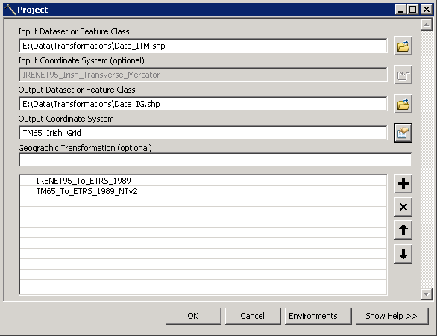

1. Click OK to execute the Project tool.

# Irish Grid to ITM in a Single Step - Create a Custom Geographic Transformation

In the last two examples in section 3, data was transformed from Irish Grid to ITM and vice versa. In both of these cases, a two-step transformation was required (two files had to be selected in the Geographic Transform dropdown list). This procedure can be simplified to a single step process. To do this, another custom geographic transformation file (gtf file) must be created.

The following steps describe how to:

* Create the custom transformation (gtf file)
* Use the new custom transformation in the Project tool

## Creating the Custom Transformation for transforming between Irish Grid and ITM

1. In ArcToolbox, go to Data Management Tools 🡪 Projections and Transformations 🡪 Create Custom Geographic Transformation.
2. For Geographic Transformation Name, enter a name for the new custom transformation, e.g. IG_To_ITM
3. For Input Coordinate System, browse to Projected Coordinate Systems🡪National Grids 🡪*(Europe)* 🡪Irish National Grid.prj

|  |  |
| --- | --- |
| j0217328 | **Note:** the *Europe* subfolder only exists in ArcGIS Desktop 10.0 and 10.1 |

1. For Output Coordinate System, browse to Projected Coordinate Systems🡪National Grids 🡪*(Europe)* 🡪IRENET95 Irish Transverse Mercator.prj
2. For Method, choose NTV2 from the dropdown list
3. Under the Parameters section, for Value, enter ireland/tm75_etrs89.gsb

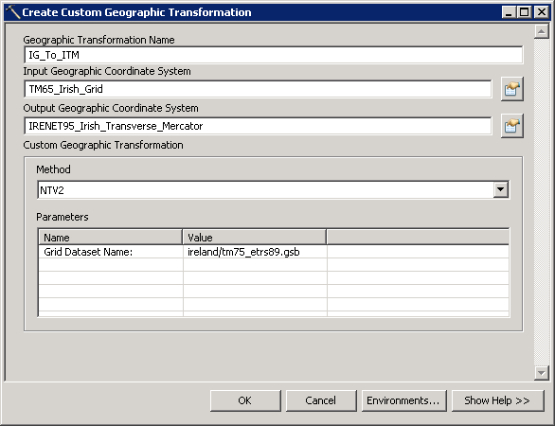

1. Click OK to create the custom geographic transformation.
2. The new gtf file will be created in the following folder:

* **Windows XP**, **ArcGIS Desktop 9.2, 9.3:** *C:\Documents and Settings\<your login>\Application Data\ESRI\ArcToolbox\CustomTransformations*
* **Windows XP, ArcGIS Desktop 10.0:** C:\Documents and Settings\<your login>\Application Data\ESRI\Desktop10.0\ArcToolbox\CustomTransformations
* **Windows XP, ArcGIS Desktop 10.1:** C:\Documents and Settings\<your login>\Application Data\ESRI\Desktop10.1\ArcToolbox\CustomTransformations
* **Windows 7, ArcGIS Desktop 9.2, 9.3**: C:\Users\<your login> \AppData\Roaming\ESRI\ArcToolbox\CustomTransformations
* **Windows 7, ArcGIS Desktop 10.0**: C:\Users\<your login\AppData\Roaming\ESRI\Desktop10.0\ArcToolbox\CustomTransformations
* **Windows 7, ArcGIS Desktop 10.1**: C:\Users\<your login\AppData\Roaming\ESRI\Desktop10.1\ArcToolbox\CustomTransformations

## Using the Custom Transformation: Irish Transverse Mercator (ITM) to Irish Grid

1. Open the Project Tool
2. For Input Dataset or Feature Class, browse to the location of the input data.
3. The coordinate system of the input data will be recognised automatically
4. For Output Dataset or Feature Class, browse to the location in which the re-projected data will be created
5. For Output Coordinate System, browse to:

Projected Coordinate Systems🡪National Grids 🡪*(Europe)* 🡪Irish National Grid.prj

1. For Geographic Transformation, select the custom transformation that was created in the previous step - “IG_To_ITM”.

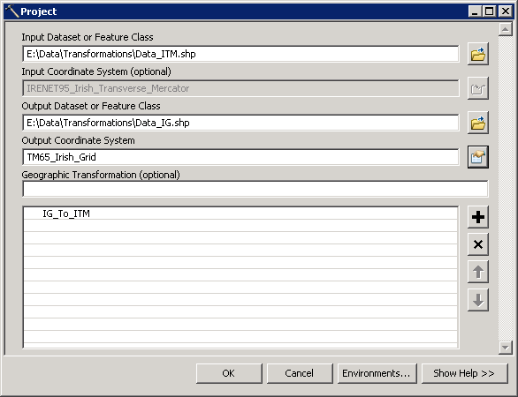

1. Click OK to execute the Project tool.

End of document

1. In **Microsoft Windows XP**, open Windows Explorer. Click Tools 🡪 Folder Options. Select the View tab. In the Advanced settings list, ensure the option “Show hidden files and folders” is selected.

   In **Microsoft Windows 7**, open Windows Explorer. Click the “Organise” button, then choose “Folder and Search Options” from the menu. Select the View tab. In the Advanced settings list, ensure the option “Show hidden files and folders” is selected.